**14. Fill in a letter template which looks like below:**

**Exercise**

* **Write a program to fill in a letter template which looks like below:**

**Sentence =      “Dear <|name|>, Thanks a lot”**

**Replace =      <|name|> with a string (some name)**

**Approach:**

**So here we did like this**

**Java : We use replace method but if we just do like this**

**String sentences = sc.nextLine();**

**String sentence = "Dear <|name|>, Thanks a lot!";**

**sentence.replace("<|name|>", sentences);**

**System.out.println(sentence);**

**It will execute this : Enter your name: Subham**

**Dear <|name|>, Thanks a lot!**

**If we want to change a string we need convert a string by storing it in   
another string variable**

**Python : We will use the .replace() method again and unlike java , we don’t need to store the string in another variable !**

**Solution 👇**

**Java :**

**import java.util.Scanner;**

**public class CodeXam {**

**public static void main(String[] args) {**

**Scanner sc = new Scanner(System.in);**

**System.out.print("Enter your name: ");**

**String sentences = sc.nextLine();**

**String sentence = "Dear <|name|>, Thanks a lot!";**

**sentence =  sentence.replace("<|name|>", sentences);**

**System.out.println(sentence);**

**}**

**}**

**output:**

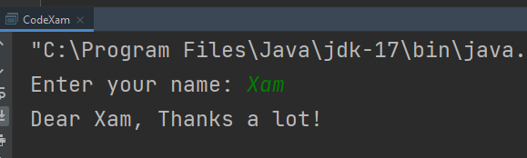

**Python :**

**name = input("Enter your name: ")**

**output = "Dear <|Name|>, Thanks a Lot !"**

**print(output.replace('<|Name|>', name))**

**output:**

